DBMS Technical Task
Dhanalakshmi K
E25AI110
BSc. Computer Science
With
Artificial Intelligence

Week 3: Seller and Inventory Management System

Aim of the Project
To design and implement a database system for managing seller details and product inventory, while maintaining relationships between sellers, products, and stock information.

Creating the Seller Table
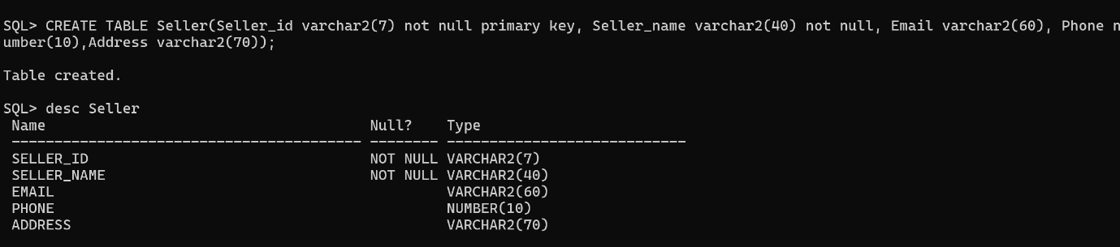

Creating the Inventory Table
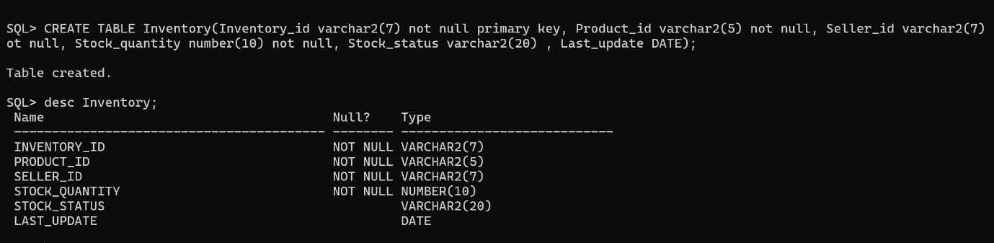

Establishing Relationships
After creating the Seller and Inventory tables, relationships were established between the tables using foreign keys. The Seller_ID in the Inventory table refers to the corresponding seller in the Seller table. Similarly, Product_ID connects the Inventory table with the Product table.
Foreign Key for Inventory Table: 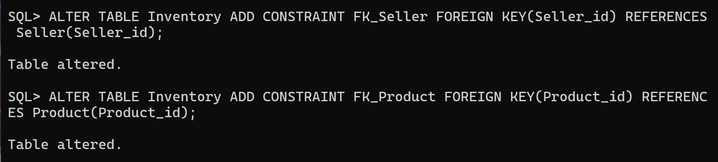

Applying Constraints for Data Integrity
applied to make sure that the database accepts only valid and meaningful data.
- Unique Email Constraint
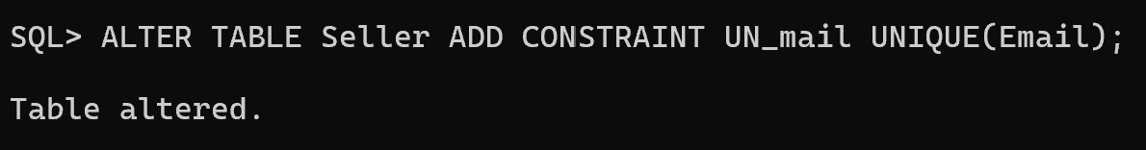
- NOT NULL Constrain
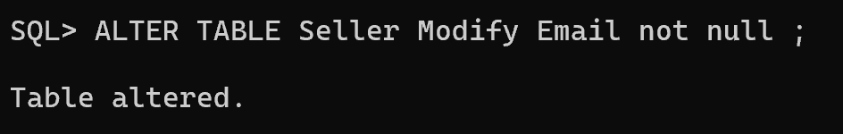
- Stock Quantity Validation
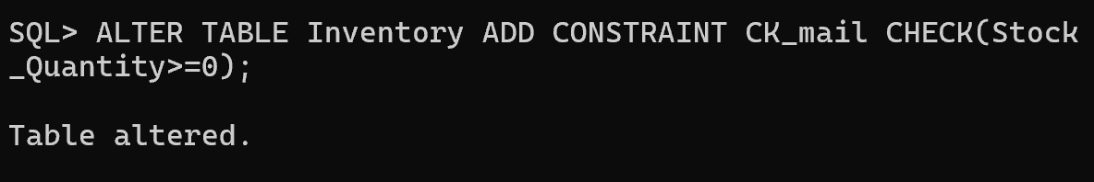

Inserting Seller Details
After completing the table design and constraints, seller details were inserted into the Seller table. The data contains the seller ID, seller name, email, phone number, and address.

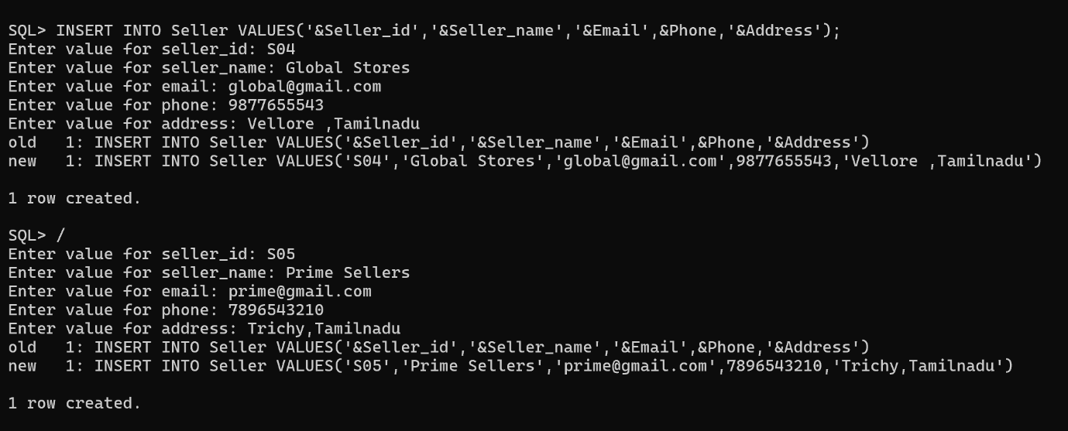

After Inserting Values :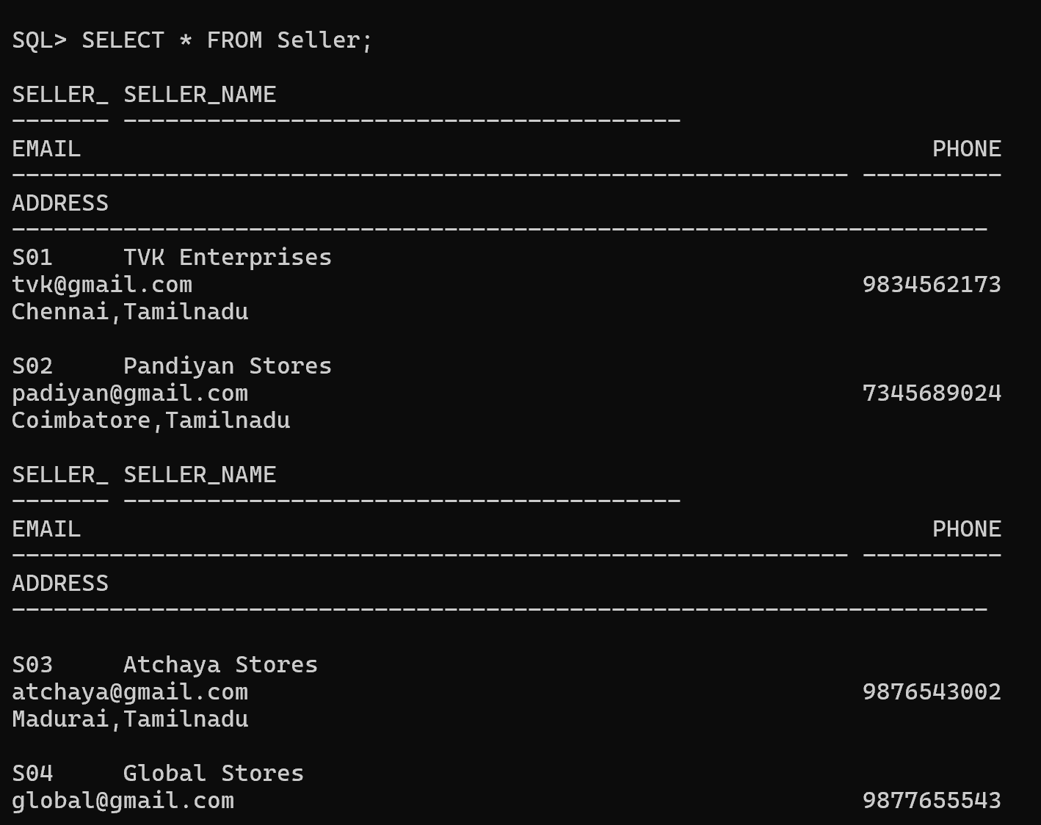

Inserting Inventory Details
After entering the seller information, inventory details were added. Each inventory record contains an inventory ID, product ID, seller ID, stock quantity, stock status, and the date of the last update.
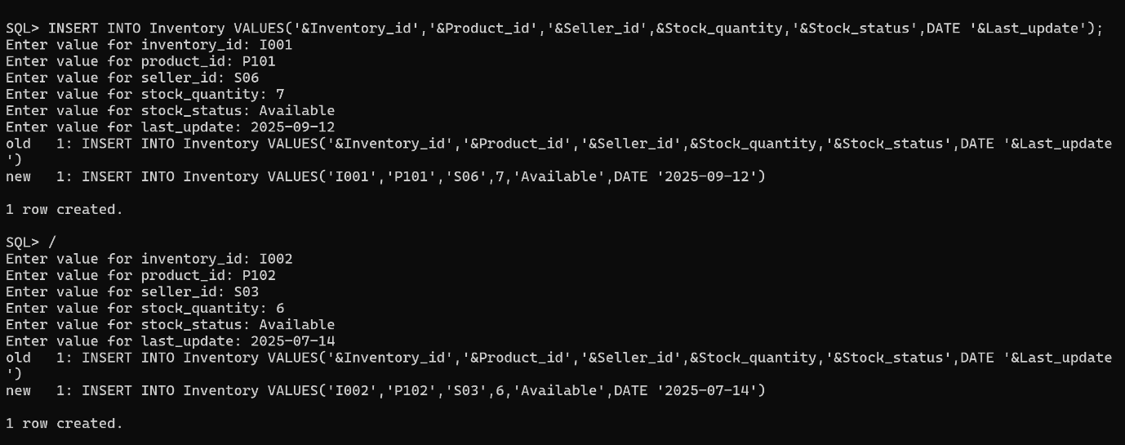

After Inserting Values: 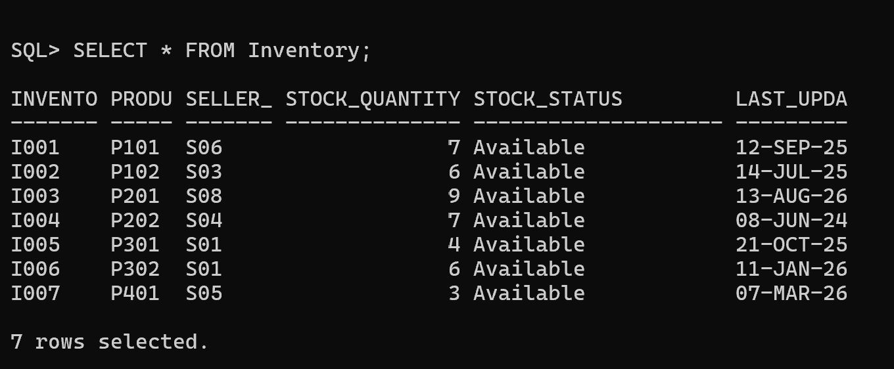

Report 1: Seller-wise Product Report
After entering the required data, SQL queries were used to extract useful information from the database. The first report focuses on the relationship between sellers and their supplied products.
The report displays the seller name, number of products supplied, and total available stock.
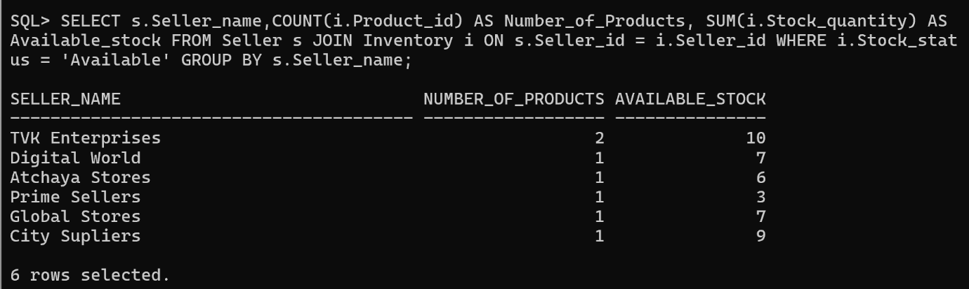
The query uses a JOIN to connect the Seller and Inventory tables. COUNT() is used to calculate the number of products, while SUM() calculates the total available stock for each seller.

Report 2: Stock Availability Report
The next report focuses on the availability of individual products. Instead of displaying only product IDs, the Product and Inventory tables are joined to display the actual product names along with their stock information.
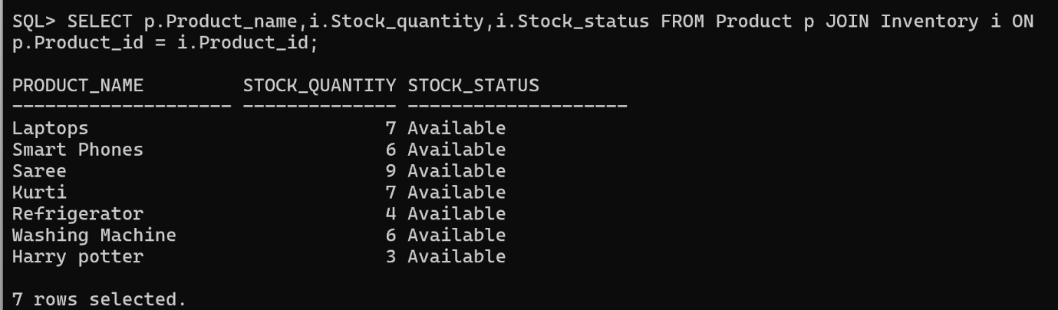
The result shows the current stock quantity and status of each product. This makes it easier to identify whether products are currently available.

Report 3: Inventory Analysis
Finally, the stored inventory data can be analyzed to understand the overall stock situation. SQL aggregate functions can be used to calculate important inventory measures such as total products, out-of-stock products, highest stock, and average stock quantity.
- Total Products Available
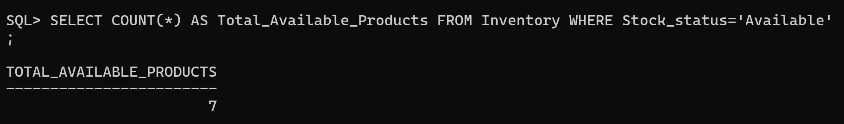
- Products Out of Stock
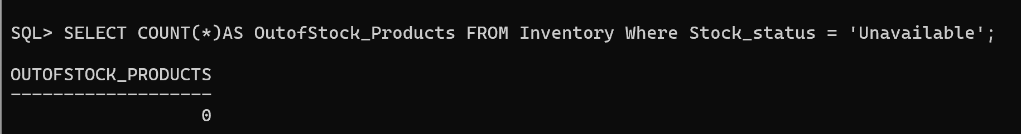
- Highest Stocked Product
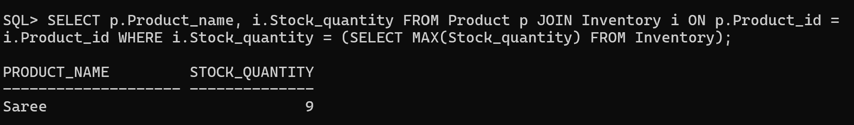
- Average inventory quantity 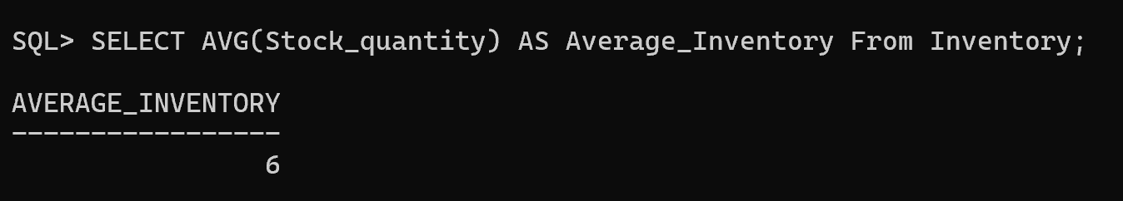
The Seller and Inventory Management System was successfully implemented using Oracle SQL. The project demonstrates the practical
use of table creation, primary keys, foreign keys, constraints, data insertion, joins, grouping, and aggregate functions.

